4th March TUESDAY :
Oral examination will be taken
5thMarch WEDNESDAY :
: The Adventure of Huckle berry Finn chapter: 8
Objective: To Topic analyze the key themes, characters, and literary devices in the chapter,
Finn, a young boy, is running away to find freedom, and he’s joined by Jim, a runaway slave. They travel down the river on a raft.
• Reading aloud helps students connect with the characters and events. read with them, pausing occasionally to discuss parts of the story fostering a deeper understanding of the text and its relevance to the overall narrative.
Methodology: • Start with a Brief Recap, will make sure the students know the basic premise of the story The Huck.
How royal strangers was captured by villagers? what they did
Who has met the Huck near the river?
What was their next plan?
Drilling of new words from word list
6th March Thursday:
Written examination
7th March Friday :
The Adventure of Huckle berry Finn chapter: 9
Sad farewells Reading and explanation
Objectives: To Topic analyze the key themes, characters, and literary devices in the chapter,
Finn, a young boy, is running away to find freedom, and he’s joined by Jim, a runaway slave. They travel down the river on a raft.
• Reading aloud helps students connect with the characters and events. read with them, pausing occasionally to discuss parts of the story fostering a deeper understanding of the text and its relevance to the overall narrative.
Methodology: • Start with a Brief Recap, I’ will make sure the students know the basic premise of the story.
How did they disguise Jim to escape from that cabin?
What story did Tom tell Jim and Huck about Miss Watson and Pap?
How Goodbye Tom and Huck Say to Jim?
Drilling of wordlist before reading.
10th March Monday:
Objective: • Students will learn the meanings of new vocabulary words from the lesson.
• They will use these words in sentences to understand their usage.
• Students will improve their reading, writing, and speaking skills by practicing new words in context.
• They will enhance their comprehension and expand their vocabulary for better communication.

TOPIC: WORD MEANING AND SENTENCES ( chapter 8 and 9 )
- Delighted – Very happy or pleased.
- I was delighted to get a new puppy for my birthday.
- Padlock – A small lock that you can open with a key or code.
- Dad used a padlock to lock the gate.
- Escape: To run away from danger or a problem.
The bird escaped from its cage and flew away.

4 Sneaked Moved quietly so no one would notice.
The cat sneaked into the kitchen to find food.
- Grin – A big, happy smile.
She had a big grin on her face when she won the game.
- Blister – A small bubble on the skin caused by rubbing or burning.
I got a blister on my foot from wearing tight shoes.
- Terrified– Very scared.
The loud thunder made me feel terrified.
- Farewell – A way to say goodbye.
We said farewell to our friends before moving to a new city.
8 Whizzed– Delighted Moved very fast with a sound.
The car whizzed past us on the road.
March 11th Tuesday:( chapter 8 and 9)
Topic: Questions and answers
Objectives will be able to reinforce, understanding of key events, characters, themes, and vocabulary while encouraging thoughtful engagement with the text.
Methodology: Begin with a quick recap of the chapter. Ask students:
- "Who are the main characters?"
- "Where does the story take place?"
- "What happened in the beginning, middle, and end?"
• Show 2-3 pictures related to the story and ask students to
Encourage students to answer in complete sentences.
QUESTIONS AND ANSWERS:
- How royal strangers was captured by villagers? what they did
- Who has met the Huck near the river?
- What was their next plan?
- How did they disguise Jim to escape from that cabin?
- What story did Tom tell Jim and Huck about Miss Watson and Pap?
- How did Tom and Huck say goodbye to Jim, and why?
- How did they assist Jim in escaping from Uncle Silas Phelps's farm?

March 12th Wednesday:
Topic: Pronouns
Objectives: By the end of the lesson, students will be able to:
- Define a pronoun.
- Identify pronouns in sentences.
- Replace nouns with appropriate pronouns.
- Use pronouns correctly in sentences.
Method:

Warm-up Activity Introduction to Pronouns
- Write a sentence on the board:
Sara likes apples. Sara eats apples every day. Sara says apples are tasty."
- Ask students: "Does this sentence sound repetitive? How can we make it better?"
- Introduce pronouns as words that replace nouns to make sentences smoother.
- Rewrite the sentence using pronouns:
"Sara likes apples. She eats them every day. She says they are tasty."
- Ask students to repeat the sentence and identify the pronouns.
- Write examples on the board:
  - He for a boy (John → He)
  - She for a girl (Sarah → She)
  - It for an object/animal (The cat → It)
  - They for more than one (Tom and Jerry → They)
  - We when including yourself (My friends and I → We)
  - You when speaking to someone (Emma, you are my friend.)
  - I for oneself (I am a student.)

Fill in the Blanks
Fill in the blanks with the correct pronoun from the box.
(I, he, she, it, we, they, you)
- My name is Sam. ___ am 8 years old.
- This is Ahmad. ___ likes to play soccer.
- Mary is my sister ___ loves to read books.
- The dog is barking. ___ is hungry.
- My friends and I are going to the park. ___ are excited!
- Ali and Sara are my classmates. ___ sit next to me in class.
- Mom, can ___ help me with my homework?
March 13th Thursday:
Topic; pronoun
Personal Pronouns (Subject and Object)
Write the chart on the board:
Subject Pronoun | Object Pronoun
I | Me
You | You
He | Him
She | Her
It | It
We | Us
They | Them

- Examples:
  - She is my sister. (subject) → I love her. (object)
They are my friends. (subject) → I play with them. (object)

Copy work (1)
Fill in the blanks with the correct object pronoun (me, you, him, her, it, us, them).
- My mother gave a gift to my sister. She gave ___ a book.
- This is my father. I love ___ very much.
- Our teacher told Sarah and Tom a story. She told ___ a fairy tale.
- My uncle took my brother and me to the park. He took ___ in his car.
- This is my favorite teddy bear. I sleep with ___ every night.
- My friends invited my family and me to their party. They invited ___ happily.
- I saw a puppy on the street. I wanted to help ___ find its owner.
14th March Friday: ( copy work 2)
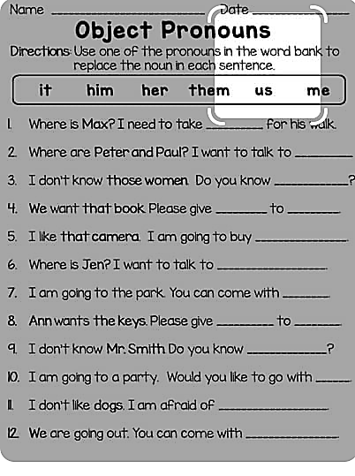
Topic: personal Pronoun

17th March Monday:

Topic: Adventure story writing:
Objective:
• Students will learn the elements of a story (characters, setting, problem, and solution).
• Students will write a short story using a graphic organizer.
• Students will share their stories with the class.
Methodology:

lesson Steps:

1. Introduction – What Makes a Good Story?
- Write "Story Writing" on the board.
- Ask students: "What makes a good story?" (Discuss characters, setting, problem, and solution).
- Read a short story example and identify these elements together.

2. Brainstorming – Planning a Story
- Use a graphic organizer to help students plan their own stories.
- Fill in four key parts:
  - Characters (Who is in the story?)
  - Setting (Where does the story take place?)
  - Problem (What challenge does the character face?)
  - Solution (How is the problem solved?)
Copy work (1)

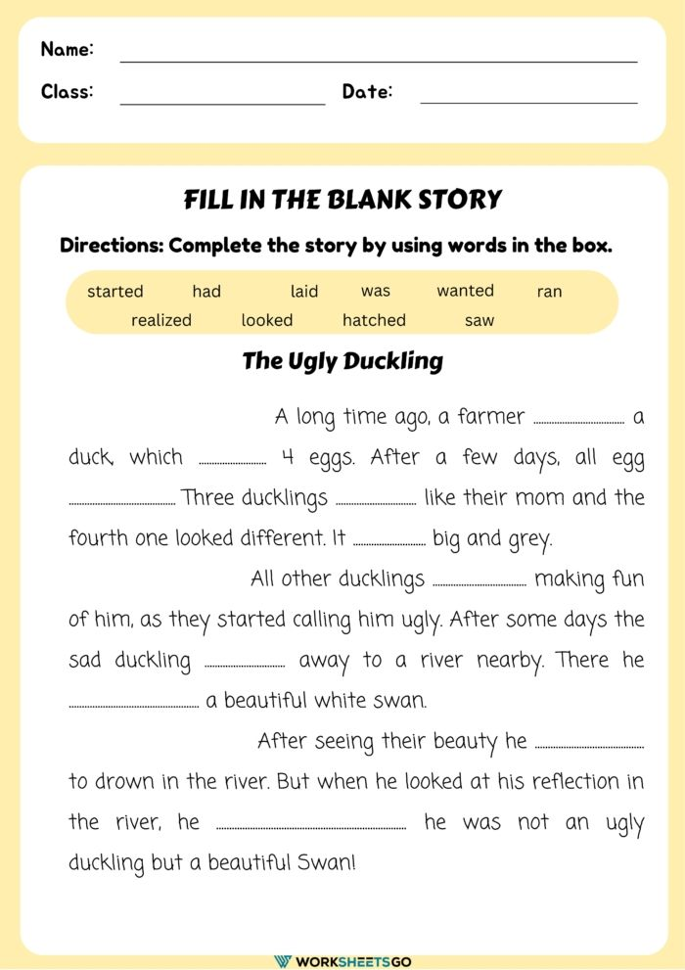
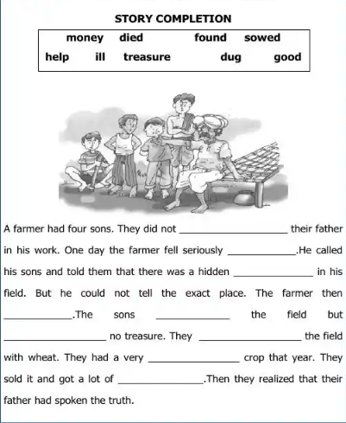

Nudged | muttered | delighted | escape | sneaked
shovel | slung | squeeze | wriggle | terrified
argue | disguise | farewell | gulping | gasping
scratch | secretly | civilized | grin | horrified
cowering | padlock | splattered | devil | squinting
desperate | grumpy | cramped | spurting | Stream
- Break out Sad farewells Chapter 8 and 9

Nudged | muttered | delighted | escape | sneaked
shovel | slung | squeeze | wriggle | terrified
argue | disguise | farewell | gulping | gasping
scratch | secretly | civilized | grin | horrified
cowering | padlock | splattered | devil | squinting
desperate | grumpy | cramped | spurting | Stream
Nudged | muttered | delighted | escape | sneaked
shovel | slung | squeeze | wriggle | terrified
argue | disguise | farewell | gulping | gasping
scratch | secretly | civilized | grin | horrified
cowering | padlock | splattered | devil | squinting
desperate | grumpy | cramped | spurting | Stream
Nudged | muttered | delighted | escape | sneaked
shovel | slung | squeeze | wriggle | terrified
argue | disguise | farewell | gulping | gasping
scratch | secretly | civilized | grin | horrified
cowering | padlock | splattered | devil | squinting
desperate | grumpy | cramped | spurting | Stream

Nudged | muttered | delighted | escape | sneaked
shovel | slung | squeeze | wriggle | terrified
argue | disguise | farewell | gulping | gasping
scratch | secretly | civilized | grin | horrified
cowering | padlock | splattered | devil | squinting
desperate | grumpy | cramped | spurting | Stream
Nudged | muttered | delighted | escape | sneaked
shovel | slung | squeeze | wriggle | terrified
argue | disguise | farewell | gulping | gasping
scratch | secretly | civilized | grin | horrified
cowering | padlock | splattered | devil | squinting
desperate | grumpy | cramped | spurting | Stream

